**100%**

**Using your textbook, labs and lecture notes to complete the following test in 3 hours.**

**Place the solution inside the HandsOnTest/CH15 folder of your repository.**

**All code submitted must be your original work.**

**Code must be uploaded to Github with the solution name HOT15 for grading.**

**EX1 [100 pts]**

Write a C# Winforms GUI application for a loan company.

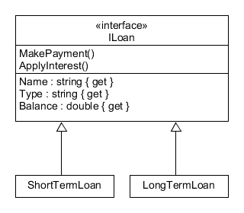

1. The lender provides two types of loans. Short-Term and Long-Term loans.
2. **Short-Term** loans have a monthly payment of $450 and an interest rate of 10%
3. **Long-Term** loans have a monthly payment of $200 and an interest rate of 5%
4. The program will allow the user to enter a loan name, amount and type.
5. Once the loan has been created the user can make payments on the loan and see the current balance before and after interest is applied.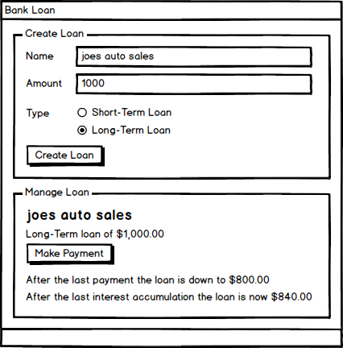
6. The program should display an error message if a negative loan amount is entered.

**ILoan**

**MakePayment()** subtracts the appropriate payment amount from the balance.

**ApplyInterest()** adds the appropriate interest amount to the balance.

**Grading**

* Controls are laid out as expected – 2 pts
* Tab order is configured – 2 pts
* Control names follow naming conventions – 2 pts
* Variable names follow naming conventions – 2 pts
* UI allows the user to create a loan as described and displayed on mock up
  + ShortTerm Loan - 10 pts
  + LongTerm Loan - 10 pts
* UI allows the user to make payments as described and displayed on mock up
  + ShortTerm Loan - 13pts
  + LongTerm Loan - 13pts
* When the loan is paid off, an appropriate message should be displayed to the user. -6pts
* UI displays an error message if the user enters a negative loan amount - 5 pts
* UI displays all monetary amounts as currency - 5 pts
* **ILoan** interface as described - 10 pts

**ShortTermLoan Class**

* Has fields for the name and balance of the loan - 2 pts
* Has a constructor that initializes all of the fields - 2 pts
* Has properties for the name, type, and balance of the loan - 2 pts
* Implements the MakePayment() method - 2 pts
* Implements the ApplyInterest() method - 2 pts

**LongTermLoan Class**

* Has fields for the name and balance of the loan - 2 pts
* Has a constructor that initializes all of the fields - 2 pts
* Has properties for the name, type, and balance of the loan - 2 pts
* Implements the MakePayment() method - 2 pts
* Implements the ApplyInterest() method - 2 pts